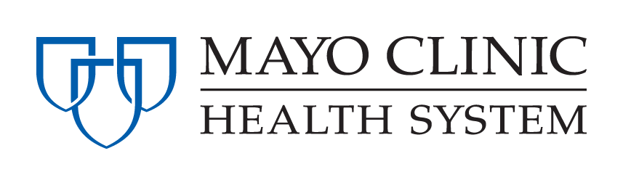

**Mayo Clinic Health System – Franciscan Healthcare La Crosse**

**Student Nurse Intern Program**

## Interest Inventory

The following information will help us to match your interests with our needs. It will be used to determine placement for those accepted into the program. Please indicate the following items according to this ranking system:

**1. Strong Interest 2. Interest 3. No Interest**

_____ Medical – General Medical, Cardiac, and Oncology

_____ Surgical – Post-op Surgical

_____ Med/Surg/Peds – General Medical, Post-op Surgical, and Pediatrics

_____ ICU/CCU

_____ Day Surgery

_____ Emergency and Urgent Care Center

_____ Family Birthplace

_____ NICU

**SCHEDULING (Schedules are prepared and available before first day of internship)**

⬩ Shift schedules will be 8 or 12 hours shifts.

* Depending on schedule assignments, nurse interns may work every other weekend or every third weekend.
* The most common schedules are a day-evening rotation or day-night rotation.

**Name:**

**School:**